Cancer Rehabilitation Day 2 Notes

[Contained within this document are links to video clips, quizzes, templates and academic evidence concerning cancer rehabilitation]

Books

- Exercise prescription physiological foundations; a guide for health, sport and exercise professionals Link

- New Guide to Medicines and Drugs, 9th Edition Link

- Metacognitive therapy for anxiety and depression Link

- Clinical Exercise Testing Link

- ACSM’s Guidelines for Exercise Testing and Prescription [10th Edition] Page 423 onwards for Cancer Link

- Cancer Metastasis, Molecular and Cellular Mechanisms and Clinical Intervention, Volume 1_ Biology and Treatment (Cancer Metastasis - Biology and Treatment) Link

Thursday Cancer Rehab Notes & Materials

- McMillian Template on Clients PAR-Q Link

- Solihull Cancer Rehab Scheme Link

- Piper Fatigue Scale Blank Template Link

- Geriatric Examination Tool Kit Norms Link

- FACIT Measurement System Full List [Link]

- Goodman, C.G. Snyder, T.E. (2013). Differential Diagnosis for Physical Therapists: Screening for Referral. (5th ed.). St. Louis, MO: Saunders Elsevier. Link

- Cuesta‐Vargas, A. I., Férnandez‐Lao, C., Cantarero‐Villanueva, I., Castro‐Sánchez, A. M., Fernández‐de‐las Peñas, C., Polley, M. J., & Arroyo‐Morales, M. (2013). Psychometric properties of the Quick PIPER: a shortened version of the PIPER Fatigue scale. European journal of cancer care, 22(2), 245-252. Link

Relevant Academic Resources

- Types of Cancer Treatment [NIC] Link

- Berg Balance Scale YouTube Videos Link 1 and Link 2

- Berg Balance Scale and Rating Scale Link

- National Cancer Institute Side Effects of Cancer Treatments Link
- Centres for Disease Control and Prevention Side Effects of Cancer Treatment Link

Video Clips [Note these exercises included are only examples]

- Video Clips Only [MD Anderson Cancer Centre] Link

- Video Clips Exercise Video for Cancer Patients: Easy #1 (Light Intensity) Link

- Video Clips Exercise During and After Cancer Link

- Video Clips Exercise & Cancer | How Targeted Exercise Can Help Fight Cancer Link

- Video Clips Live Well After Breast Cancer | Cardio Workout #1 Link

- Video Clips Live Well After Breast Cancer | Strength Workout #1Link

Exercise Related Studies

- Cormie, P., Zopf, E. M., Zhang, X., & Schmitz, K. H. (2017). The impact of exercise on cancer mortality, recurrence, and treatment-related adverse effects. Epidemiologic reviews, 39(1), 71-92. Link

Summary findings
Findings of this review support the view that exercise is an important adjunct therapy for the management of cancer. A significant body of literature now exists that provides credible evidence of the beneficial impact of exercise on disease and patient outcomes. However, these data need to be interpreted carefully as considerable heterogeneity exists (not all the same findings so difficult to fully know) in the nature and quality of study designs, interventions, assessments, and subsequent findings. Despite existing limitations, the evidence to date supports recommendations for people with cancer to avoid inactivity and to engage in regular exercise. This includes participating in moderate to vigorous intensity aerobic and resistance exercise as endorsed by leading international organizations (ACSM, 2010; Rock et al ,2012; Ligibel and Delingers, 2013).
- Tian, L., Lu, H. J., Lin, L., & Hu, Y. (2016). Effects of aerobic exercise on cancer-related fatigue: a meta-analysis of randomized controlled trials. Supportive Care in Cancer, 24(2), 969-983. Link

Summary findings

Exercise should be considered as part of the cancer care standards to mitigate the effects of Cardiorespiratory fitness (CRF), particularly in adult breast and nasopharyngeal cancer patients who have completed adjuvant therapy. From this meta-analytical study, suggests that supervised aerobic exercise [i.e., exercise for 20–30 min/session, or exercise three times/week had a small ES on CRF. Exercise for 50 min/session and exercise two sessions/week had a significant ES, and 8 weeks of exercise had a moderate effect]. Clinical professionals could make the exercise prescription referring to the above results with the patients’ status combined. In addition, exercise adherence is very important for the management effect. Future research should focus on the monitoring methods and improvement of the aerobic exercise adherence. cancer patients.

- Keilani, M., Hasenoehrl, T., Baumann, L., Ristl, R., Schwarz, M., Marhold, M., ... & Crevenna, R. (2017). Effects of resistance exercise in prostate cancer patients: a meta-analysis. Supportive Care in Cancer, 25(9), 2953-2968. Link

Summary findings

In the present meta-analysis, Keilani and colleagues reported that resistance exercise [RE] is an effective approach in counteracting increase of body fat and loss of muscle mass, muscle strength, and physical performance in patients suffering from prostate cancer. Resistance exercise should be an important part in multidisciplinary and interdisciplinary cancer rehabilitation of this patient [population] group as it appears to have important potential to reduce not only treatment-related side effects but also detrimental psychosocial health issues. Many prostate cancer patients are undergoing long-term androgen deprivation therapy ADT, while substantial ADT side effects are already measurable after 3 months of treatment [Alibhai et al., 2010]. Therefore, application of RE as an early countermeasure as well as within a long-term rehabilitation process of prostate cancer is essential in optimum supportive care of prostate cancer patients. However, further and larger studies examining different protocols of RE and their effectiveness at different treatment and disease stages should be key components of future research in this field.

- Hardee, J. P., Porter, R. R., Sui, X., Archer, E., Lee, I. M., Lavie, C. J., & Blair, S. N. (2014, August). The effect of resistance exercise on all-cause mortality in cancer survivors. In Mayo Clinic proceedings (Vol. 89, No. 8, pp. 1108-1115). Elsevier. Link

Summary findings

This study provides preliminary evidence that resistance exercise [RE] at least 1 day per week was associated with reduced risk of all-cause mortality in cancer survivors. The findings along with previous scientific evidence provides additional clinical significance and rationale for the integration of RE during cancer survival. The mechanisms associated with these benefits have not to been clearly defined and further research on this issue is required. Additionally, it is necessary to determine if a specific type of physical activity may be more beneficial for certain cancers. Therefore, future prospective randomized controlled trials should be designed to address potential mechanisms between RE and health outcomes, including all-cause and disease-specific mortality, during cancer survival.

- Kimball, B. C., Asiedu, G. B., & Thompson, C. A. (2018). Building a Healthy Body After Cancer: Young Adult Lymphoma Survivors' Perspectives on Exercise After Cancer Treatment. Journal of adolescent and young adult oncology, 7(2), 217-229. Link

Summary findings

Fatigue and patient irritation with post cancer physical limitations are major barriers to exercise for young adult survivors, whereas support from others, data tracking, and survivor-specific resources are facilitators. Interventions that include fitness tracking technology, are individually tailored, and/or create a community with other young adult survivors may be successful in this population.

- Stout, N. L., Baima, J., Swisher, A. K., Winters-Stone, K. M., & Welsh, J. (2017). A systematic review of exercise systematic reviews in the cancer literature (2005-2017). PM&R, 9(9), S347-S384. Link

Summary findings
Based on this review, exercise interventions [EI] have a strong evidence base to support their global inclusion in every individual’s cancer care plan. The EI of care is ideally designed in the context of known disease treatments and anticipated side effects of treatment and is overseen by a health care provider with specialised knowledge and skills in cancer-specific exercise and cancer rehabilitation. Despite a growing body of evidence to support numerous EI across various cancer disease conditions and cancer treatment-related impairments, the supporting infrastructure for exercise planning and implementation for the cancer population is essentially vague. Efforts to strengthen consistency in clinical trial reporting, develop clinical practice guidelines, and integrate exercise and rehabilitation services into the cancer delivery system are desired.
- D’Ascenzi, F., Anselmi, F., Fiorentini, C., Mannucci, R., Bonifazi, M., & Mondillo, S. (2019). The benefits of exercise in cancer patients and the criteria for exercise prescription in cardio-oncology. European journal of preventive cardiology, 2047487319874900. Link

Summary notes

Key recommendations for exercise prescription in cancer patients.
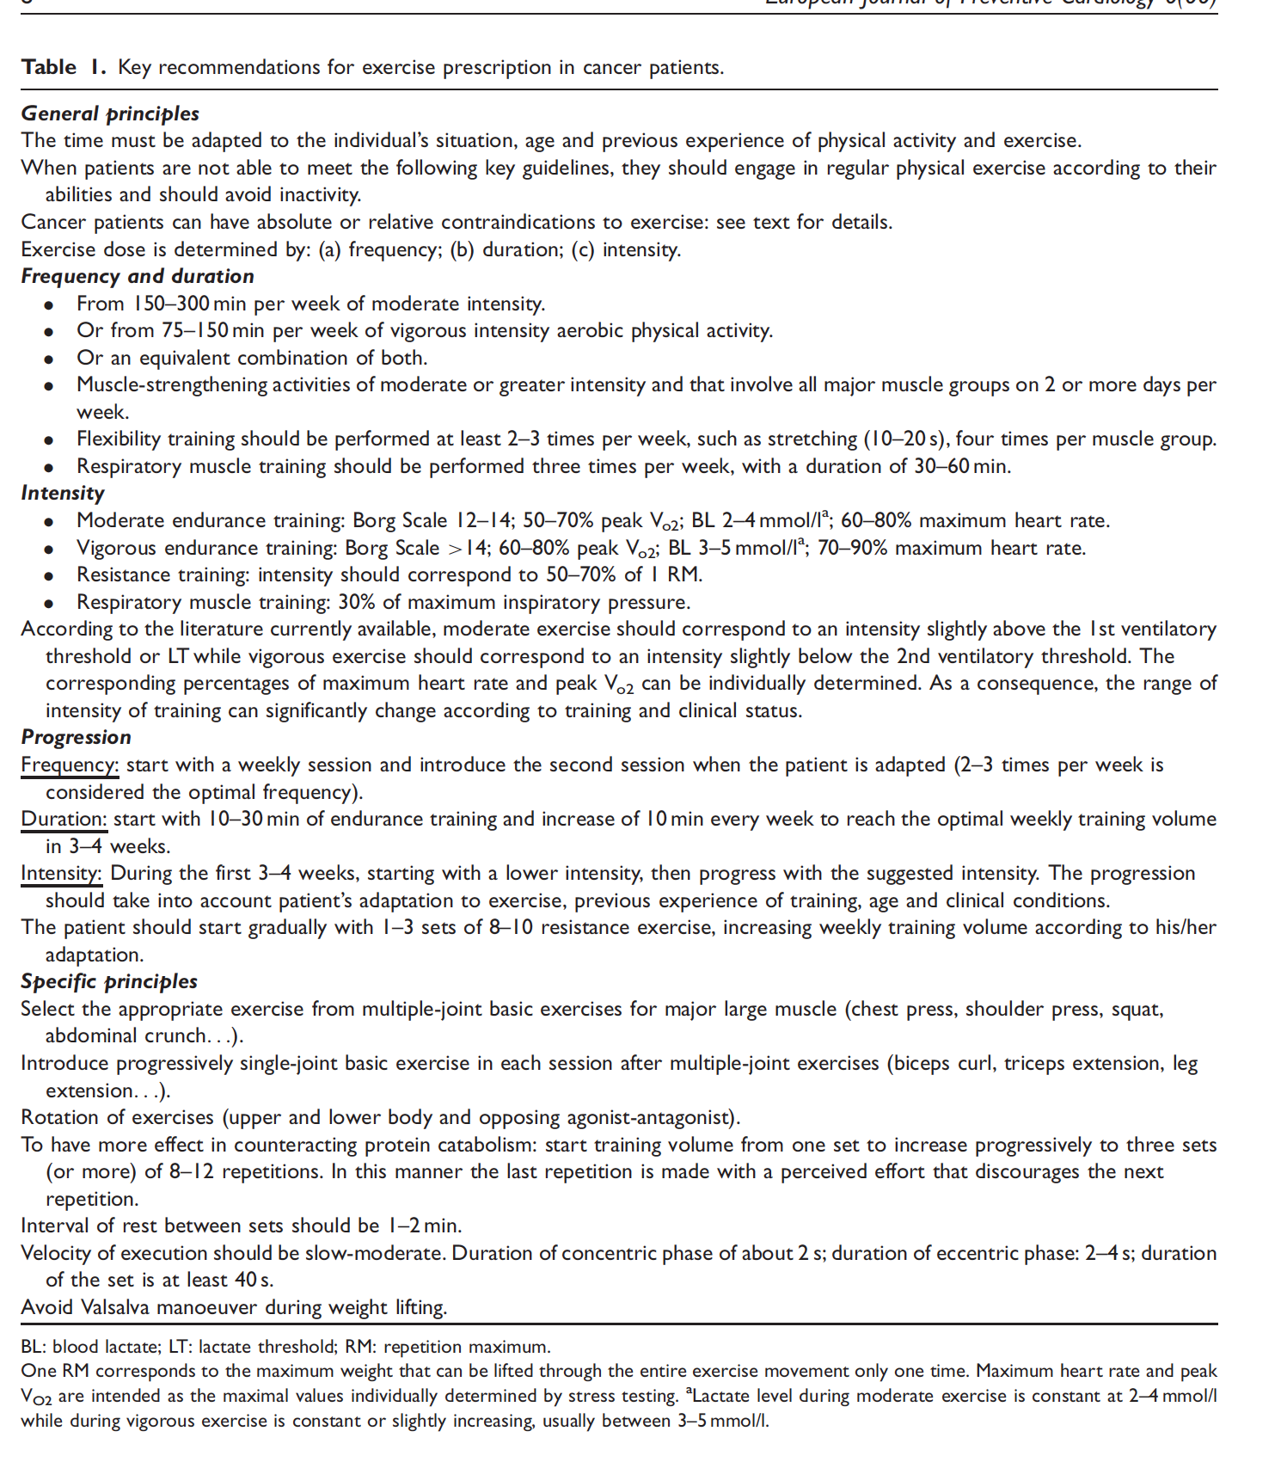

- Campbell, K. L., Winters-Stone, K. M., Wiskemann, J., May, A. M., Schwartz, A. L., Courneya, K. S., ... & Morris, G. S. (2019). Exercise guidelines for cancer survivors: consensus statement from international multidisciplinary roundtable. Medicine & Science in Sports & Exercise, 51(11), 2375-2390. Link

- McTiernan, A., Friedenreich, C.M., Katzmarzyk, P.T., Powell, K.E., Macko, R., Buchner, D., Pescatello, L.S., Bloodgood, B., Tennant, B., Vaux-Bjerke, A. and George, S.M., 2019. Physical Activity in Cancer Prevention and Survival: A Systematic Review. Medicine and science in sports and exercise, 51(6), pp.1252-1261. Link

- Schmitz, K.H., Campbell, A.M., Stuiver, M.M., Pinto, B.M., Schwartz, A.L., Morris, G.S., Ligibel, J.A., Cheville, A., Galvão, D.A., Alfano, C.M. and Patel, A.V., 2019. Exercise is medicine in oncology: engaging clinicians to help patients move through cancer. CA: a cancer journal for clinicians, 69(6), pp.468-484. Link

- Battaglini, C. L., Mills, R. C., Phillips, B. L., Lee, J. T., Story, C. E., Nascimento, M. G., & Hackney, A. C. (2014). Twenty-five years of research on the effects of exercise training in breast cancer survivors: a systematic review of the literature. World journal of clinical oncology, 5(2), 177. Link

- [1RM Breast Cancer) Cormie, P., Galvao, D. A., Spry, N., & Newton, R. U. (2013). Neither heavy nor light load resistance exercise acutely exacerbates lymphedema in breast cancer survivor. Integrative Cancer Therapies, 12(5), 423-432. Link

- NCCN Guidelines (2020) Survivorship Link

- Cormie, P., Atkinson, M., Bucci, L., Cust, A., Eakin, E., Hayes, S., McCarthy, A.L., Murnane, A., Patchell, S. and Adams, D., 2018. Clinical Oncology Society of Australia position statement on exercise in cancer care. Medical Journal of Australia, 209(4), pp.184-187. Link

- Hayes, S.C., Newton, R.U., Spence, R.R. and Galvão, D.A., 2019. The Exercise and Sports Science Australia position statement: Exercise medicine in cancer management. Journal of science and medicine in sport, 22(11), pp.1175-1199. Link

- Cheema, B., Gaul, C.A., Lane, K. and Singh, M.A.F., 2008. Progressive resistance training in breast cancer: a systematic review of clinical trials. Breast cancer research and treatment, 109(1), pp.9-26. Link

ACSM (2019) Cancer-related health outcome with stated sufficient evidence for development of FITT prescription
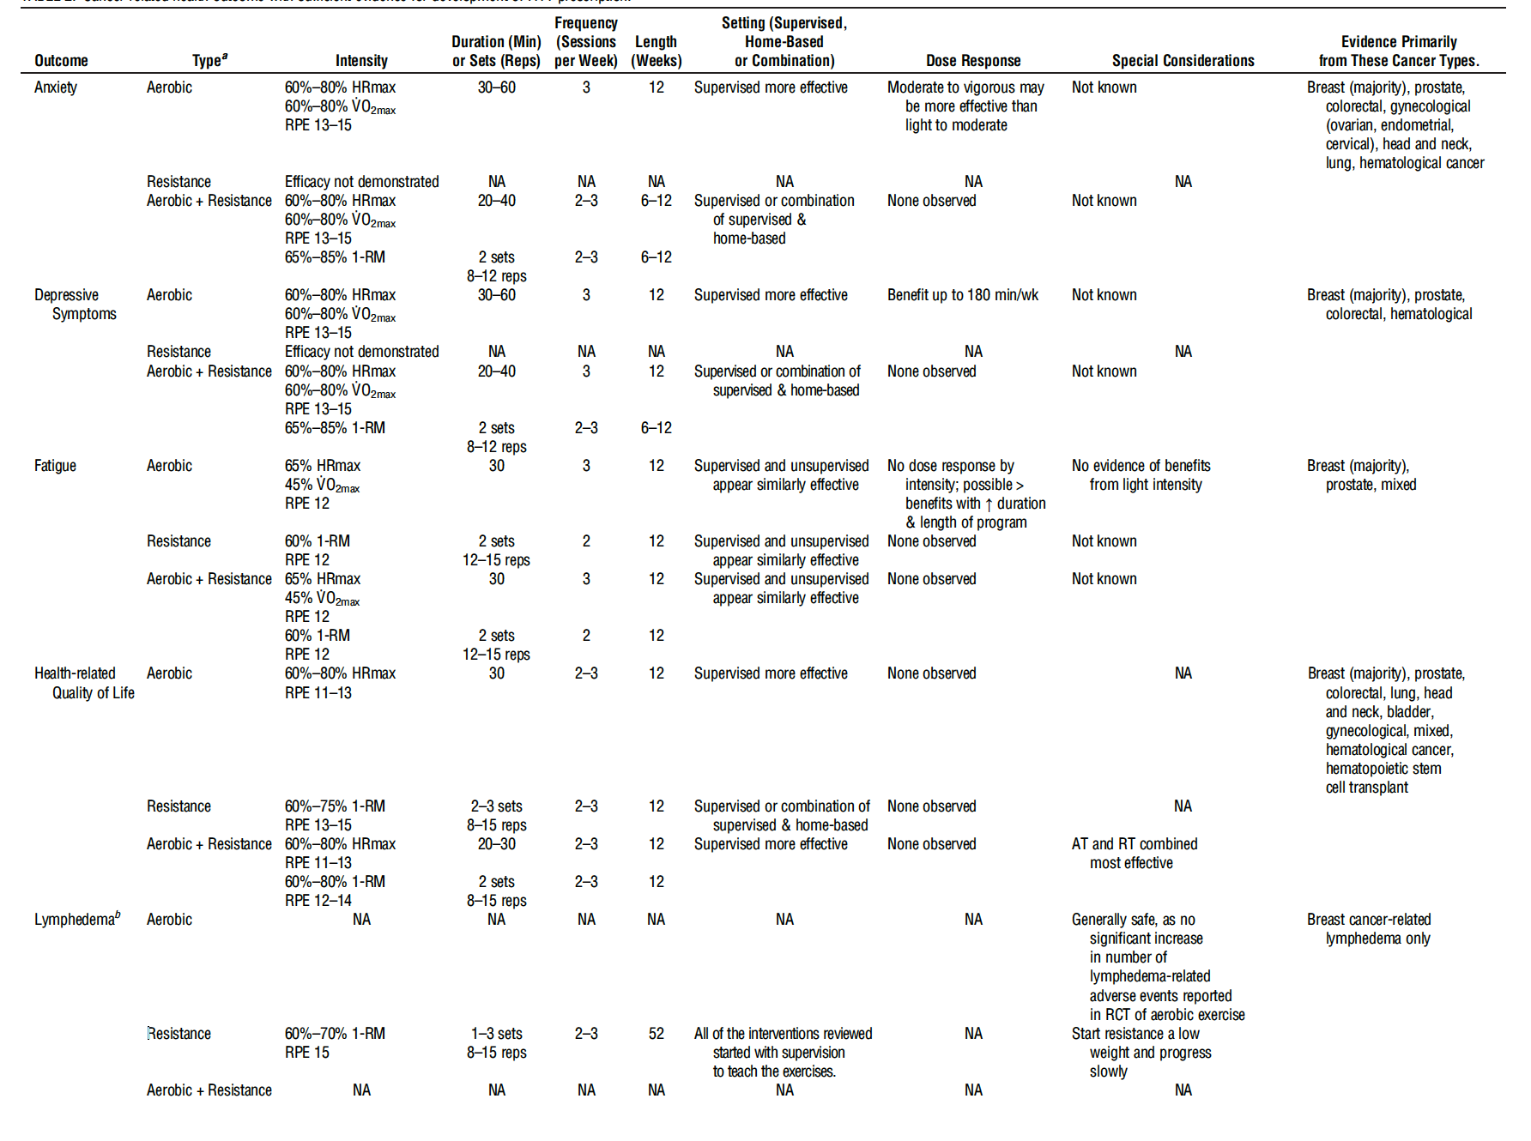

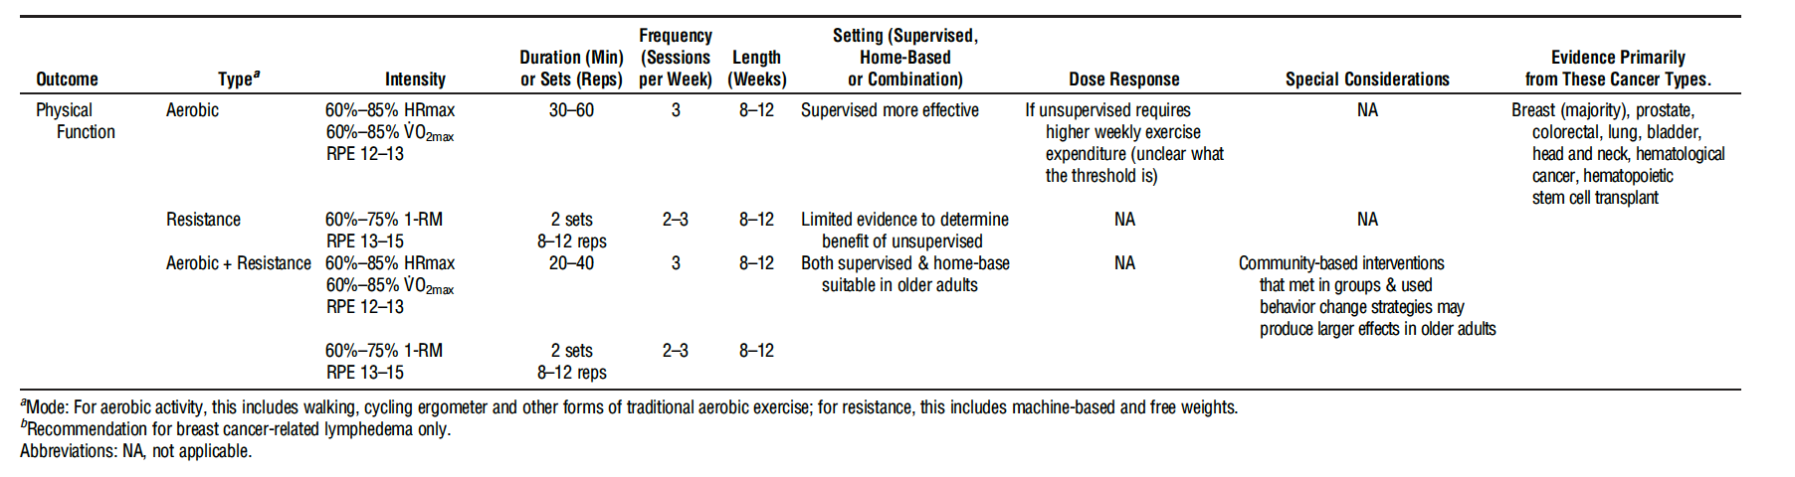

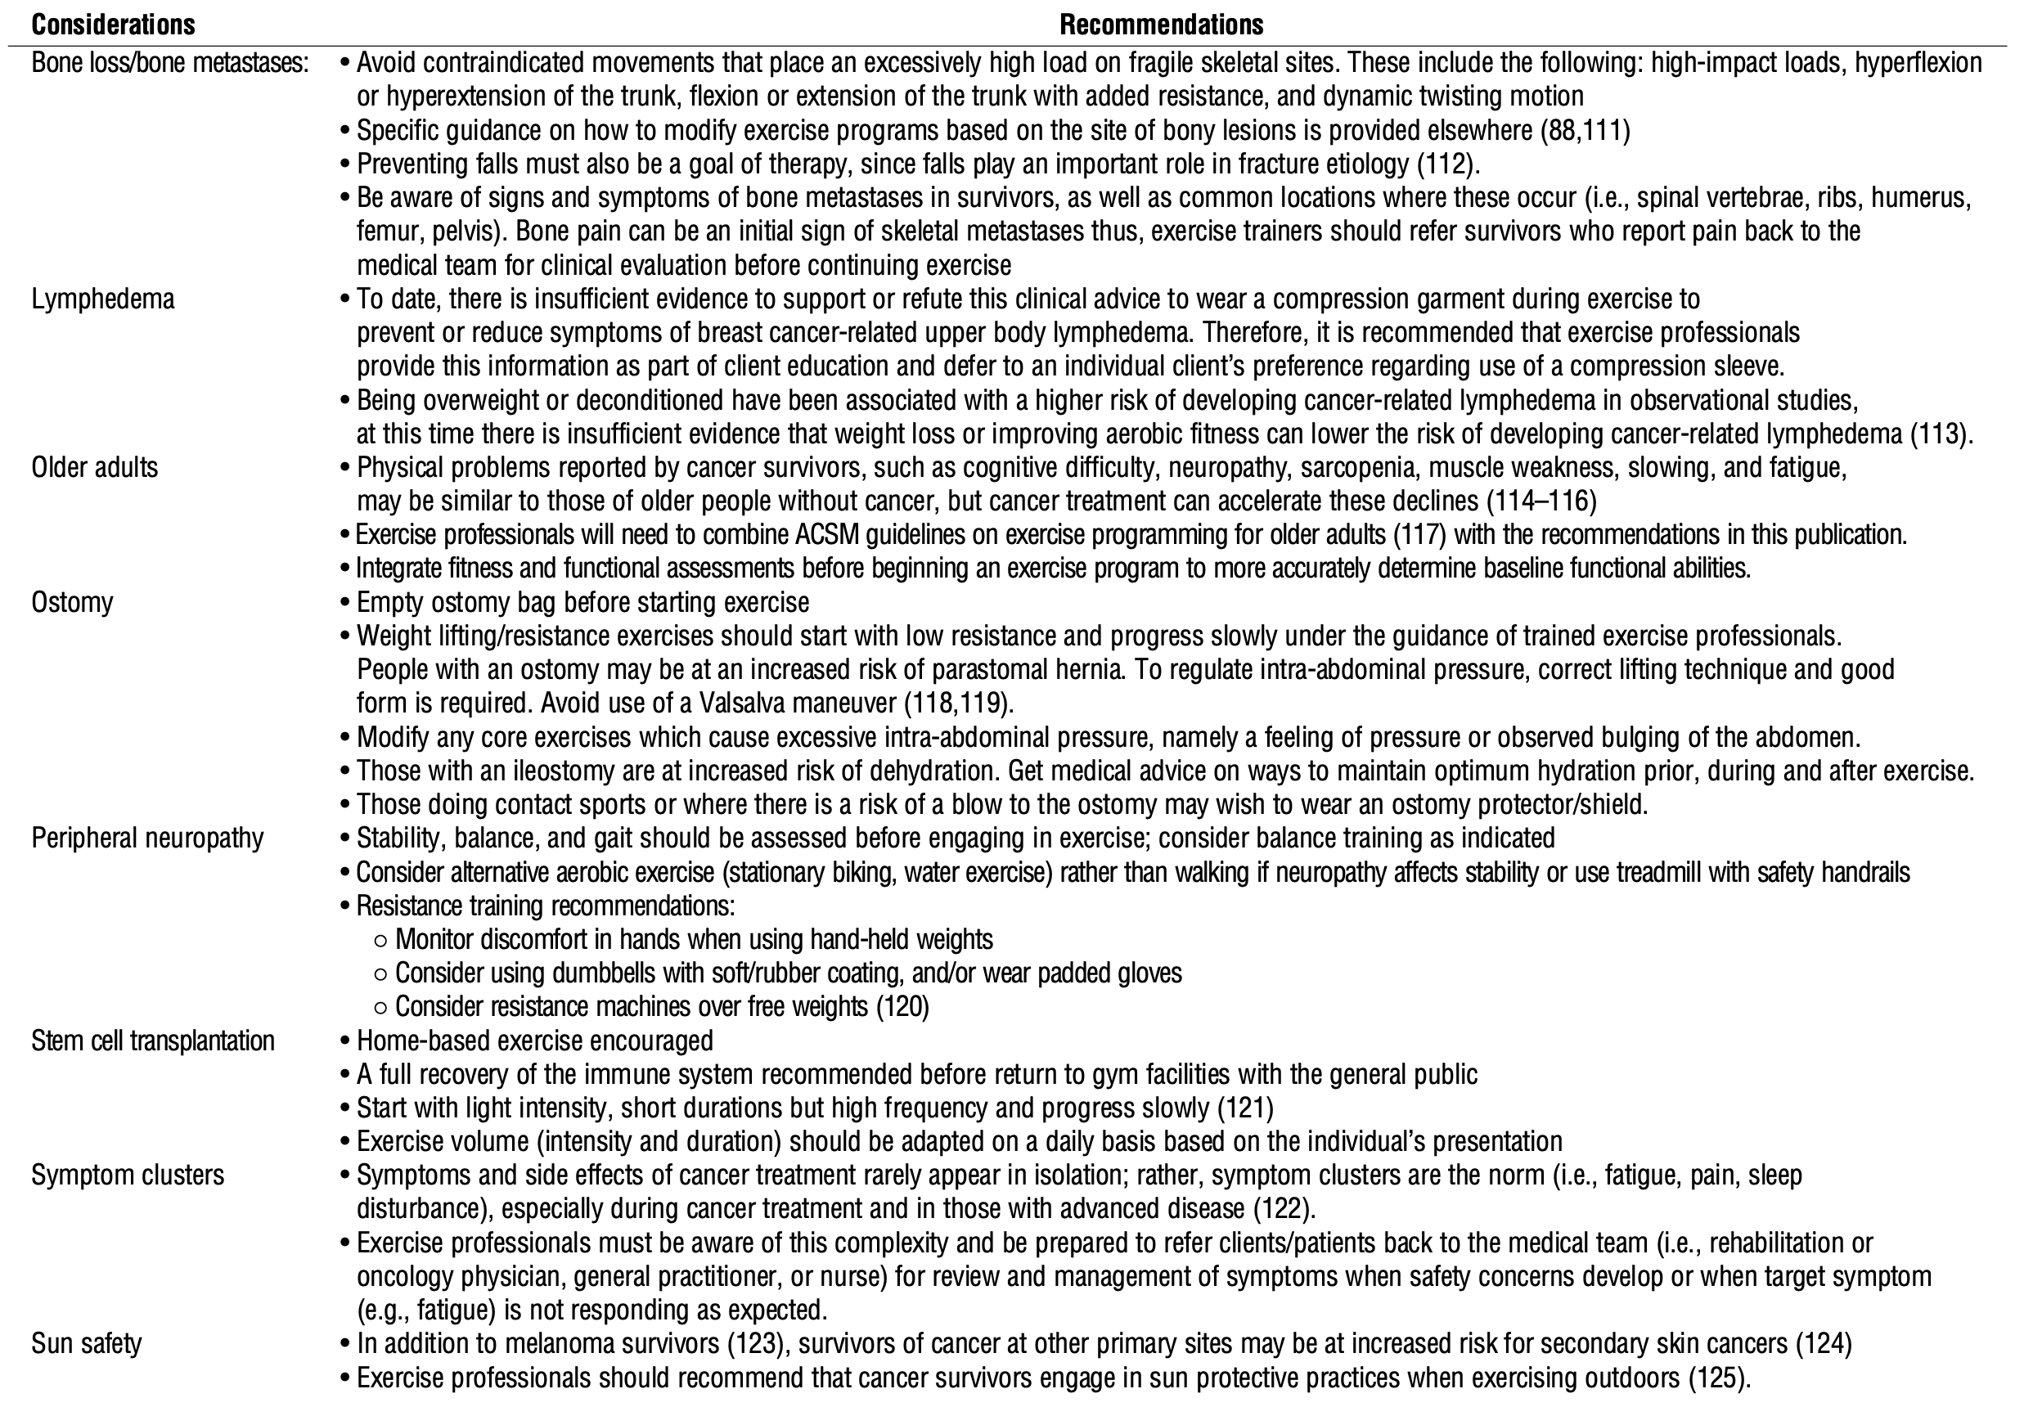
ACSM (2019) Exercise programming considerations for specific cancer survivors [Table 5].

References from ACSM 2019 Recommendations on Physical Function [PF]

- Buffart L M, Kalter J, Sweegers M G, et al. Effects and moderators of exercise on quality of life and physical function in patients with cancer: an individual patient data meta-analysis of 34 RCTs. Cancer Treat Rev. 2017; 52:91–104. Link

Summary Point of PF

Exercise and specifically supervised exercise improve PF of inpatients with cancer with different demographic and clinical characteristics during and following treatment (ß = 0.18, 95%CI = 0.13;0.23). Effects on PF were significantly larger for supervised than unsupervised interventions (ß difference in effect = 0.10, 95%CI = 0.01;0.20). Although effect sizes are small, there is evidence to support the implementation of exercise as part of cancer care.

- Sweegers, MG, Altenburg, TM, Chinapaw, MJ, et al. Which exercise prescriptions improve quality of life and physical function in patients with cancer during and following treatment? A systematic review and meta-analysis of randomised controlled trials. Br J Sports Med. 2018;52(8):505–13. Link

Summary Point of PF

Exercise interventions, particularly when supervised, have statistically significant and small clinical benefit on self-reported QoL and PF in patients with cancer. Unsupervised exercise intervention effects on PF were larger when prescribed at a higher weekly energy expenditure.

- Swartz MC, Lewis ZH, Lyons EJ, et al. Effect of home- and community-based physical activity interventions on physical function among cancer survivors: a systematic review and meta-analysis. Arch Phys Med Rehabil. 2017;98(8):1652–65. Link

- Strasser, B., Steindorf., K., Wiskemann, J. and Ulrich, C.M., 2013. Impact of resistance training in cancer survivors: a meta-analysis. Medicine & Science in Sports & Exercise, 45(11), pp.2080-2090. Link

