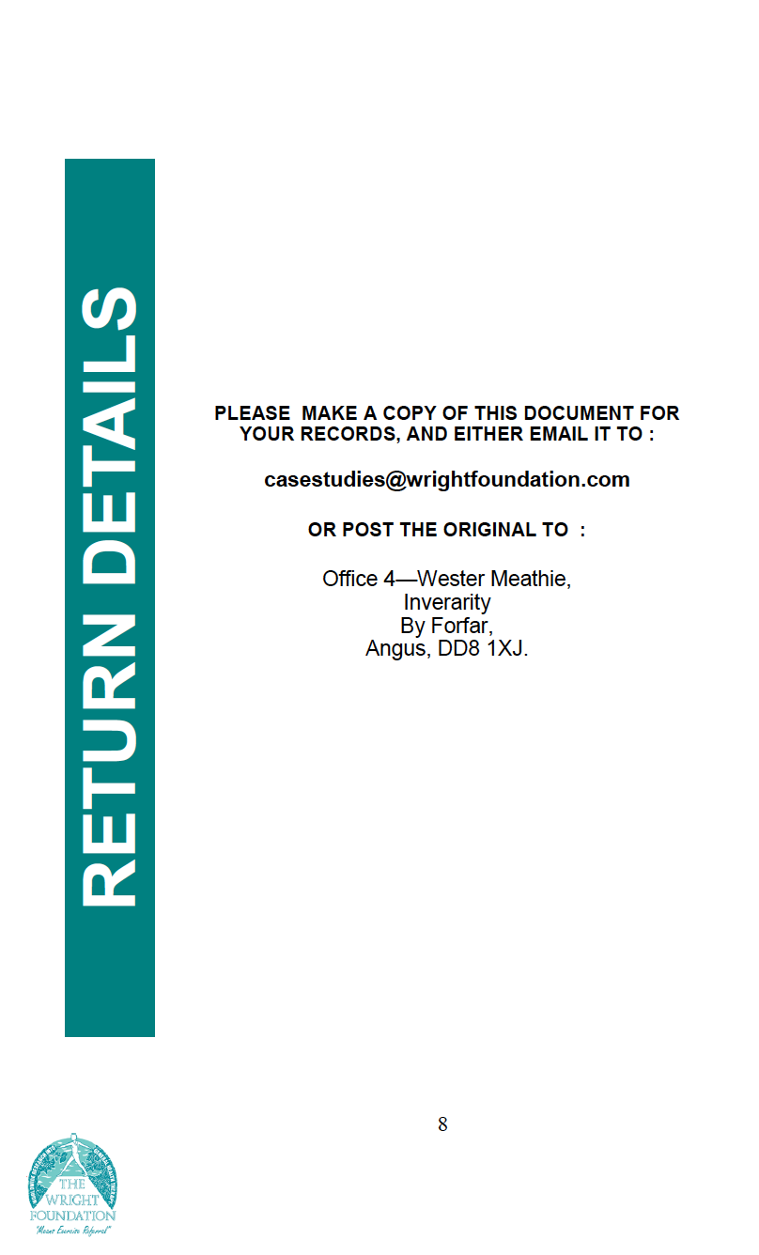

DETAILS | Office 4—Wester Meathie,
 | PLEASE MAKE A COPY OF THIS DOCUMENT FOR
 | YOUR RECORDS, AND EITHER EMAIL IT TO :
 | casestudies@wrightfoundation.com
 | OR POST THE ORIGINAL TO :
RETURN | Inverarity
 | By Forfar,
Angus, DD8 1XJ.

8

HOSPITAL ATTENDANCE RECORD
Leading by Achievement & Example
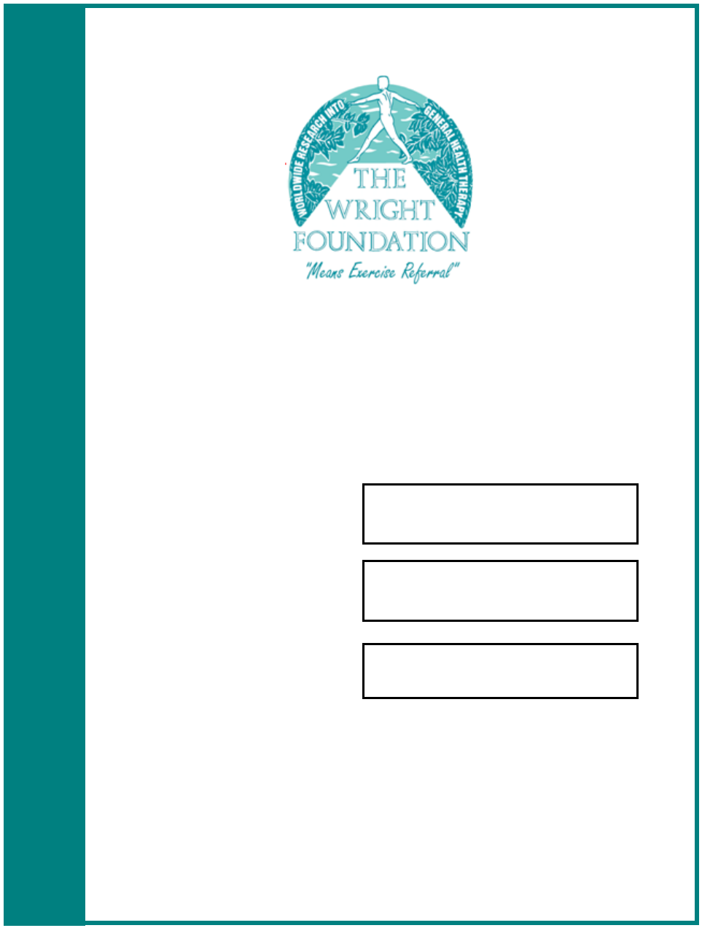

PULMONARY
REHABILITATION

“in the community”

NAME

COURSE ATTENDED

DATE

Pulmonary Rehabilitation Sessions
hospital attendance record

a. Office 4—Wester Meathie, Inverarity, By Forfar, Angus, DD8 1XJ. t. 01307 469055

- info@wrightfoundation.com w. www.wrightfoundation.com

VISIT REQUIREMENTS

Viewing of Pulmonary Rehabilitation

You are required to attend at least four sessions (totalling at least eight hours) viewing Pulmonary Rehabilitation over a maximum of five weeks with-in a local hospital.

You will view patients on their initial visit to the Pulmonary Rehabilitation programme to under-stand the physical condition and their ability to undertake an activity schedule. It is important that you understand the considerations as the patient progresses through the full pulmonary pro-gramme, in particular, how their condition is assessed.

During these stages of progression, you must view and understand the changes to the patient/client’s condition and attitude to exercise/activity. This is particularly important as the patient completes their Pulmonary Rehabilitation hospital pro-gramme.

2

Please outline your general impressions of the Pulmonary Rehabilitation sessions you have observed. Minimum 100 words.

7

NAME OF HOSPITAL

DATE OF SESSION

TIME OF SESSION
FROM: _{TO:}
To:
From:

BRIEF OUTLINE OF SESSION (50 words minimum)

SESSION 4

HOSPITAL REPRESENTATIVE NAME (BLOCK CAPITALS)

HOSPITAL REPRESENTATIVE POSITION

HOSPITAL REPRESENTATIVE SIGNATURE

6
NAME OF HOSPITAL

DATE OF SESSION

TIME OF SESSION
To:
From:
FROM: TO:

BRIEF OUTLINE OF SESSION (50 words minimum)

SESSION 1

HOSPITAL REPRESENTATIVE NAME (BLOCK CAPITALS)

HOSPITAL REPRESENTATIVE POSITION

HOSPITAL REPRESENTATIVE SIGNATURE

3

NAME OF HOSPITAL

DATE OF SESSION

TIME OF SESSION
To:
To:
From:
FROM: TO:

BRIEF OUTLINE OF SESSION (50 words minimum)

SESSION 2

HOSPITAL REPRESENTATIVE NAME (BLOCK CAPITALS)

HOSPITAL REPRESENTATIVE POSITION

HOSPITAL REPRESENTATIVE SIGNATURE

4
NAME OF HOSPITAL

DATE OF SESSION

TIME OF SESSION
To:
From:
FROM: TO:

BRIEF OUTLINE OF SESSION (50 words minimum)

SESSION 3

HOSPITAL REPRESENTATIVE NAME (BLOCK CAPITALS)

HOSPITAL REPRESENTATIVE POSITION

HOSPITAL REPRESENTATIVE SIGNATURE

5

