Students Name –

Presentation Stroke [with notes]

Course Venue – Online

Course Date – 12th July – 15th July 2022

Word Count -
Table of Contents
Section 1- 3
Section 2 4
Section 3 5
Section 4 6
Section 5 7
Section 6 10
Section 7 11
Section 8 12
Section 9 13
References 14
Appendix 15

Section 1- Create a summary statement of your client explaining his/her medical diagnoses.

A 68 year old female has suffered a stroke – occlusion of the superior division of the left middle cerebral artery.
Effects of the stroke:
- Paralysis of the right face and arm
- Loss of sensation to touch on right face and arm
- Inability to answer questions but able to understand
- Ability to write down thoughts more easily than speak
Discharge into community care and following a course of physiotherapy has regained some ROM in her right arm. Facial expressions have also improved considerably.
Medications on discharge:
- Aspirin
- Angiotensin II receptor inhibitor
- Statin
Mood is fine – no depression. Frustration at not being ablt effectively communicate and play with her grandchildren. Her big family “keeps her going”.
Physiology:
- BMI: 32
- RHR: 62bpm
- RBP: 128/72 (medicated)
Section 2 – Provide details of any other information you may be interested in finding out either from your client and/or her specialist, giving a rationale for each.
- More information about the physio therapy:
Rationale: What exercise has been implemented and the success of each movement, length of physio sessions able to tolerate, levels of fatigue throughout each session, flexibility and current CR fitness levels. This will help to prescribe the progression for the client onto her next phase of recovery with us.
- Previous history of activity/exercise:
Rationale: What did she enjoy before her stroke, what was her level of fitness and activity before the event.
- Goals and aspirations:
Client wants to play and communicate with grandchildren again. What specific goals in the short term (first 4-6 weeks) does she have.
What medium term goals does she have 12-16 weeks. What long term goals (end of first year and on) does she have.
- Barriers to attending;
Are there any times or days that are better for client to attend (re. lifts/travel, support etc.); Previous experience and feelings about attending a gym or a small group exercise class; Any other functional issues (not related to event) to be aware of – previous injury/comorbidities etc.
- Understanding of situation:
How much does the client understand of the effects of this exercise and managing expectations effectively.

Section 3 - Which tests/assessments would you choose? Give a rationale for your choices and method of securing/storing/transmitting the information.

- 6 minute walk test:
Rationale: A test that is recognised as easy to replicate under the ame conditions, therefore providing an effect and repeatable test.
To effectively provide a baseline for CV fitness. As only arm and face affected walking is still possible.
To enable an effective assessment of gait and changes in biometric physiology of client.
Information is stored on a highly secure national database run and managed by the Public Health Wales National Exercise Referral Team.
- Functional shoulder mobility / grip test:
Rationale: Easily repeatable and simple test to show progression with strength and power for the affected side and the progression of strength and power in the unaffected arm too.
Information is stored on a highly secure national database run and managed by the Public Health Wales National Exercise Referral Team.
- Talk Test:
A frustration of the client is the ineffective communication with her grandchildren following the event. We will work on facial strength and mobility exercises as advised by the physio team and use this too assess progress and to help with the prescription of the sessions
- As standard we will carry out the following assessments:
EQ5D
SPAQ
WEBWMS
Health Questionnaire (PARQ)
NERS Wales 1st Consultation Assessment

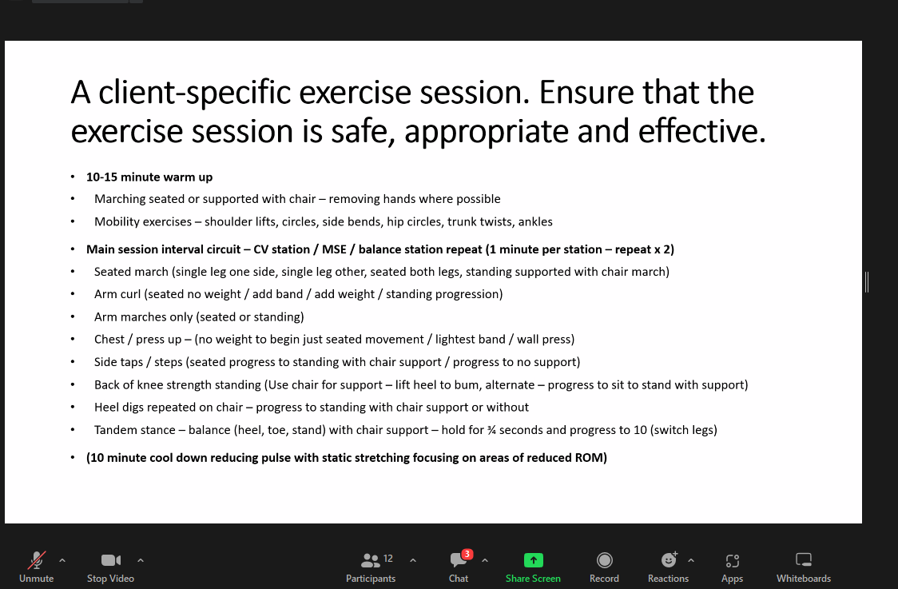
Section 4 – Design a prospective 12-week programme of exercise, which you deem to be safe, appropriate, and effective for your client.

Week | Monday | Tuesday | Wednesday | Thursday | Friday | Saturday | Sunday | Intensity | Additional comments
1
2
3
4
5
6
7
8
9
10
11
12

Key: -
Section 5 - Provide a detailed example of typical exercise session from your programme, assuming that she/he is feeling motivated for the session, based on the depth of information that you used for the practical assessment on your course.
Clients training goals:
Date:

Warm up – component duration

[Modify this table as you see fit]

Overview of content, including mobility, pulse raising (CV machine as needed) and component length | Equipment and duration | Level/ speed | RPE/HR/Talk Test/Observation | Adaptations or alternatives
Main Component – component duration
[Modify this table as you see fit]

Exercise | Equipment and duration of activity | Level/ speed | Intensity | Adaptations or alternatives | Adaptations or alternatives to suit client
Body weight exercise (including any functional/motor skills exercises appropriate for the client) |  |  | Sets/reps/rest or duration of activity
Cool down/flexibility – component duration

[Modify this table as you see fit]

Cool down (if a re-warm or pulse lowering phase is required, please detail in the space below)
CV activity / post-workout stretches | Time and intensity range | Additional information
Note: Post-workout stretches (circle as applicable) – indicate which stretches are maintenance (M) and which are developmental (D):

Section 6 - Justify your exercise programme regarding safety, appropriateness, and effectiveness.

Section 7 - Explain what considerations you would have when ensuring the referral location (i.e., gym, etc.) is suitable for your client; ensure you consider physiological and psychosocial components.

Section 8 - Create a detailed agreed programme for continued intervention/engagement with your client, this may be signposting or development of other services.

Section 9 - Develop an information/promotional leaflet or flyer about the benefits of neurological rehabilitation exercise referral scheme. Design it so it aims at the patients and the medical professional from whom you wish to receive referrals

References

Appendix

