- Study the list of bones below and indicate whether they belong to the axial or appendicular skeleton (delete incorrect answer).

Bone(s) | Axial or Appendicular
Carpal bones | Axial or Appendicular
Sternum | Axial or Appendicular
Fibula | Axial or Appendicular
Hyoid bone | Axial or Appendicular
Ilium | Axial or Appendicular
5th Lumbar Vertebrae | Axial or Appendicular

- Complete the table below classifying the following bones and identifying their primary function and location:

Bone | Classification | Primary Function | Location
Radius

Carpal bones

Scapula

Patella

Vertebra

- Identify the anatomical components of the synovial joint below and describe the functions of each.

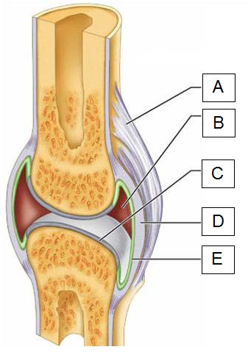

 | Component | Function
A
B
C
D
E

- In the table below, name the six classes of synovial joint giving at least one example of each.

Name of joint type | Example i.e. shoulder

- Give a brief description of the following types of movement:

Types of Movement | Brief Description
Abduction:

Adduction:

Flexion:

Extension:

Plantar Flexion:

Circumduction:

- There are several factors that may limit the range of movement at a major synovial joint. List 4 of these factors and identify what the effects might be.

Factor | Effect on Range of Movement

